Women’s Shoe Store Performance Dashboard
-Analysis Report-

--------------------------------------------------------------------------------------------------------------
Prepared by Ramsheena
06-03-2026

1.Project Overview

The Women’s Shoe Store Performance Dashboard is a comprehensive analytical solution developed in Power BI to evaluate sales performance, product demand, branch efficiency, and target achievement across multiple locations.

The primary goal of this project is to transform raw shoe sales data into meaningful business insights, enabling management to optimize:

- Product sales performance (categories, colors, sizes, pricing)
- Branch-level efficiency (regional comparisons, growth trends)
- Revenue growth and profitability (actual vs target achievement)
- Inventory planning (size and color distribution)
- Strategic decision-making (seasonal trends, top-performing products)

The dashboard covers 5 key analysis areas:

1.Home
2.Overview
3.Product performance
4.Branch and city analysis
5.Target achievement & forcast

This project supports data-driven decision-making through interactive visuals, KPI tracking , drill-down analysis, dynamic filtering capabilities.

2.Dataset Sammary

The dataset used for the Women’s Shoe Store Sales Analysis project contains detailed transactional data representing retail operations across multiple branches and product categories.
The dataset include :
Total Rows : ~11 lakh rows
Total Columns : 20
Tables And Key Fields

1.sales (Fact table)
Key columns:
- Sale_id
- Branch_id
- Shoe_id
- Sales_date
- Quantity_sold
- Total_price
2. Branches (Dimension table)
Key columns:
- Branch_id
- Branch_name
- City
- Manager_name
3.Shoes (Dimension table)
Key columns:
- Shoe_id
- Category
- Color
- Size
- Price
4.Sales_targets ( dimension table)
Key columns:
- Branch_id
- Month
- Sales_target
- Unit_target

Key Characteristics of Dataset
- Granularity: Transaction-level sales data.
- Coverage: Multiple branches (e.g., Jeddah, Khobar, Riyadh).
- Attributes: Shoe categories, colors, sizes, prices.
- Targets: Monthly branch-level targets for revenue and units.
- Period: Full-year coverage (Jan–Dec).
Data Cleaning & Preparation
Before building the Power BI model, the following data preparation steps were performed:
- Checked datasets for missing or blank values and corrected them.
- Removed duplicate records to maintain data accuracy.
- Converted columns to correct data types
- Created proper relationships between Sales
- Created measures required for analysis
Overall, the dataset was validated and prepared to ensure accuracy, consistency, and reliability for reporting and visualization.

Data Model Overview

The data model for the Women’s Shoe Store Sales Analysis Dashboard is designed using a Snowflake Schema to ensure optimal performance, simplified relationships, and efficient filtering in Power BI.
Tables
- Fact Table: Sales
- Dimension tables: Branches , Shoes
- Subdimension table : Sales_targets

Relationships:
From Table Column To Table Column Type
Shoes shoe_id sales shoe_id 1 → *
Branches branch_id Sales branch_id 1 → *
Branches branch_id Sales_Targets branch_id 1 → *
The sales_target table is a specialized dimension table that is connected to the branches table . This data model is a star schema .

5. Key DAX Measures (KPIs)

Total sales Revenue = SUM ( Sales(6)[total_price] )
Total target = SUM ( Sales_target[total_price] )
Total Sales Target = SUM('Sale_target[SalesTarget])
Total Orders = COUNTROWS ( Sales (6))
Total Units Sold = SUM ( Sales(6)[quantity_sold] )
Total Target % = DIVIDE([Total Sales Revenue], [Total SalesTarget], 0)

6. Analysis & Insights
1. Executive Overview Dashboard
Key Findings
- Total revenue exceeded 5M, surpassing the overall target of 4M.
- Achievement % across all branches averaged >120%
- All branches consistently outperformed targets.
- Revenue growth peaked in October and December, aligning with holiday demand.
2. Product Performance Dashboard
Key Findings
- Boots and Heels generated the highest revenue.
- Black and White were the best-selling colors.
- Casual and Ballerina categories underperformed compared to premium categories.
- Revenue distribution across categories shows concentration in a few high performers.

3. Branch & city Dashboard
Key Findings
- Jeddah, Khobar, and Riyadh branches contributed almost equally (~1.6M each).
- Balanced branch performance indicates strong regional presence.
- No single branch dominates revenue, reducing dependency risk.
- Monthly revenue trends show synchronized growth across all branches.
- Seasonal peaks are consistent across regions.

4. Target Achievement & Forecast Dashboard

- Overall achievement %: 123%.
- Each branch exceeded its target revenue.
- Forecasting shows continued growth into Q4.
- Jeddah achieved the highest % (131%), followed by Riyadh (127%), Khobar (113%).
- Targets appear conservative compared to actual performance.

Final Conclusion
The Women’s Shoe Store Performance Project reveals a strong business model with consistent revenue growth, balanced branch contributions, and clear product leaders. Seasonal demand peaks highlight opportunities for targeted promotions, while conservative targets suggest room for more ambitious goal-setting.
- Better branch and regional sales planning – balanced contributions across Jeddah, Khobar, and Riyadh support efficient resource allocation.
- Improved product and inventory optimization – insights into top categories (Boots, Heels), best‑selling colors (Black, White), and popular sizes (39–40) guide stocking strategies.
- Enhanced performance monitoring – achievement % consistently above 100% highlights strong execution and identifies areas for more ambitious target setting.
- Stronger decision support – seasonal trends (October, December peaks) and forecast analysis enable proactive marketing and inventory planning.
The dashboard serves as a reliable decision-support tool for monitoring and improving women’s shoes store sales performance.

Dashboard Overview

1.Executive Sales Overview
Purpose
provide executives and decision-makers with a clear, high-level view of overall sales performance. It consolidates multiple perspectives of the business into one screen so leaders can quickly assess whether targets are being met and where attention is needed.

Key metrics(KPI card)
- Total sales revenue : 5M
- Total sales target : 4M
- Total orders : 10K
- Total unit sold : 25K
- Target achievement % : 1.29

Visuals used
KPI cards : revenue,target,orders , unit sold , target achievement
Clustered bar chart : Branch performance analysis
Pie chart : sales by category
Line chart : Revenue by month
Slicers : Month , City

Filters / slicers
Month(Jan - Dec)
City(Jeddah , Khobar, Riyadh)
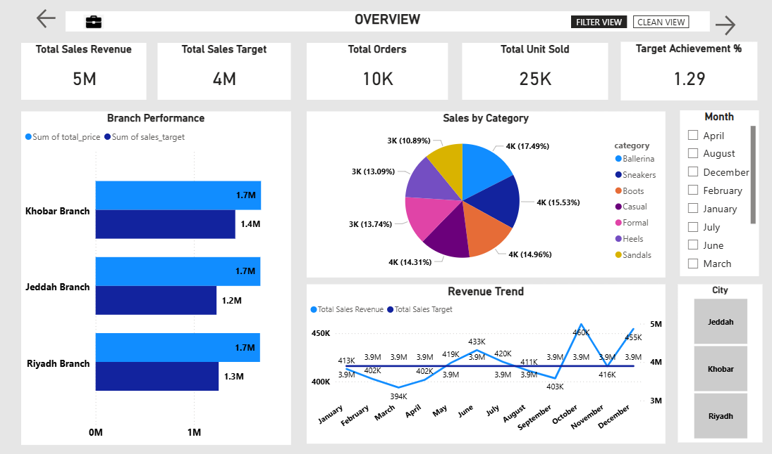

Key insights
- Total Revenue: 5M, which is above the target of 4M.
- Achievement %: 129% → business is performing strongly and consistently exceeding goals.
- Orders & Units: 10K orders and 25K units sold, showing healthy demand.
- All branches exceeded their targets, with Jeddah showing the largest gap between actual and target.
- Customers prefer casual and versatile styles (Ballerina, Sneakers, Boots) over Sandals and Heels.
- Targets remained constant, but actual revenue showed variability, highlighting seasonal buying patterns.

2.Product Performance Analysis

Purpose
It help managers and analysts understand which specific products or product groups are driving business outcomes and where adjustments are needed.purpose of this Performance Tracking by Category,Customer Preference Insights ,Operational Decision Support.

Key metrics(KPI cards)
Total revenue by category : 5M
Total orders : 10K
Total unit sold : 25K

Visuals used
Clustered bar chart : Revenue by category
Donut chart : Most sold category
Clustered column chart : Revenue by color
Slicer : Category
KPI cards : revenue by category , orders , unit sold

Filters / slicers
Category
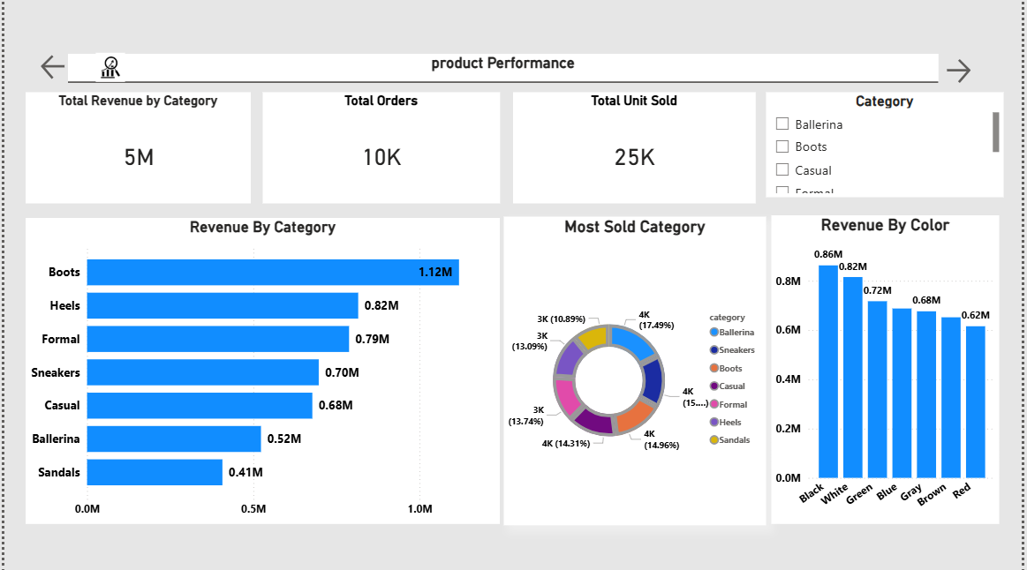

Key insights
- Neutral colors (Black, White) dominate revenue, showing customer preference for versatile, classic tones. Bright colors (Red, Brown) underperform.
- Boots consistently outperform in both revenue and units.
- Neutral colors dominate sales, aligning with fashion preferences for versatile footwear.
- Formal and Heels sell many units but generate lower revenue, suggesting lower price points.
- Seasonal demand likely influences category mix, with Boots peaking in colder months
3.Branch And City Analysis

Purpose
The purpose is to give stakeholders a clear, comparative view of how different branches and cities are performing, so they can quickly identify strengths, weaknesses, and opportunities. it serves that purpose Performance Comparison ,Trend Monitoring , Geographic Insights ,Balanced View, Target Tracking .

Key metrics(KPI cards)

Total achievement : 1.24
Total revenue : 5M

Visual used
Line chart : Monthly revenue by branch
Map : revenue and orders by city
Table : branch sales performance
Pie chart : sales by city
KPI cards : total achievement , revenue
Slicers : city , sales date

Filters/slicers
City(Jeddah , Khobar, Riyadh)
sales date(1/1/2024 - 12/31/2024)
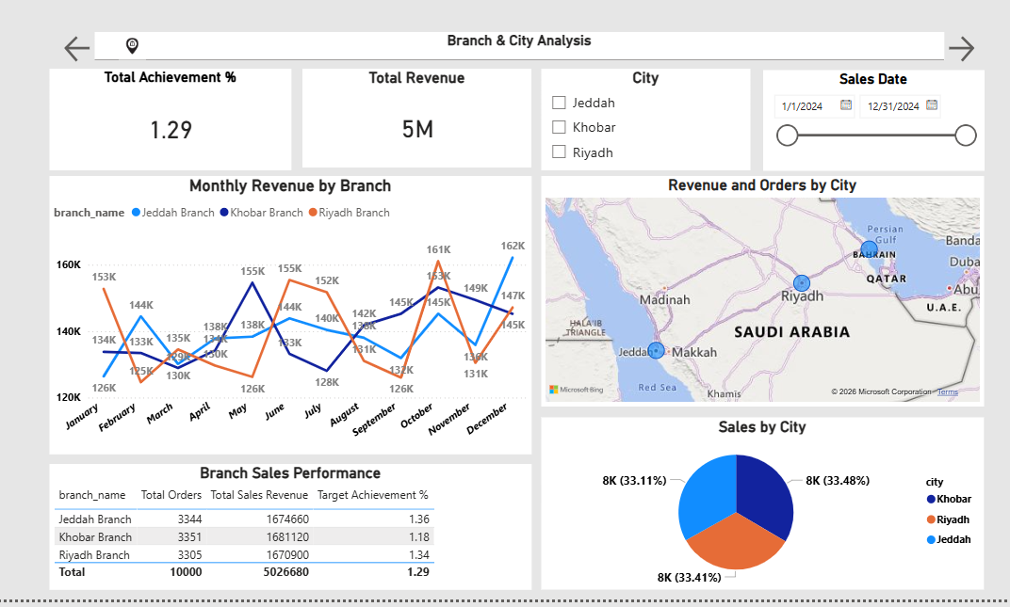

Key insights

- Balanced sales distribution across Jeddah, Khobar, and Riyadh (~33% each), showing equal market penetration without a dominant branch. Jeddah Branch leads in efficiency, achieving the highest target % (1.36%) despite similar order volumes to other branches.
- Khobar Branch underperforms on achievement (1.18%) even with the highest order count, signaling a need for strategic support.
- Revenue trends remain flat across months (120K–160K range), indicating limited growth momentum and potential need for new campaigns.
- Overall achievement % is very low (1.29%), suggesting either unrealistic targets or underperformance across all branches.

4.Target Achievement And Forecast Analysis
Purpose
The purpose is to help executives and managers evaluate how well each branch is performing against its sales targets, while also tracking progress over time . It focus Target Monitoring , Branch Comparison, Trend Analysis ,Forecasting & Planning ,Executive Oversight.

Key metrics(KPI cards)
Target achievement %: 1.23

Visuals used
KPI cards : target achievement %
Clustered bar chart : actual vs target revenue by branch
Line chart : achievement % trend over time
Table : branch performance and target
Guage : revenue VS target
Slicers : sales date ,branch name

Filters / slicer
Sales date( 1/1/2024 - 12/31/2024)
Branch name(Jeddah branch , Khobar branch, Riyadh branch )

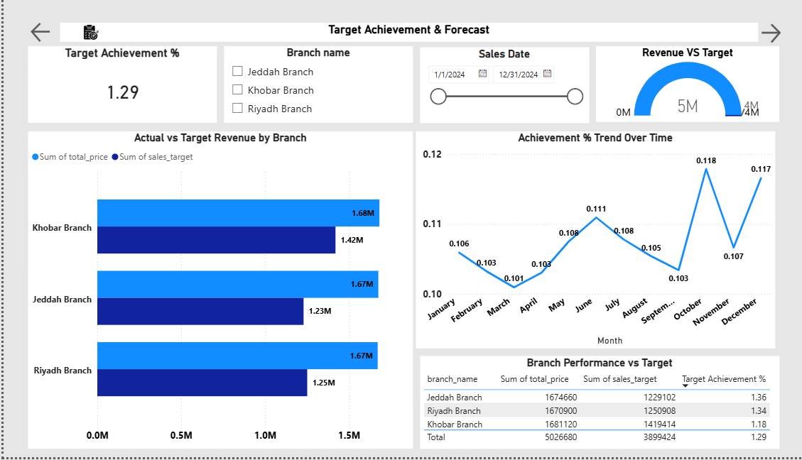

Key insights
- Consistent overachievement: All branches exceeded targets.
- Top performer: Jeddah branch achieved 131%, leading overall performance.
- Opportunity: Khobar branch needs focus to raise achievement % closer to Jeddah and Riyadh.
- Forecast reliability: Upward trend suggests sustained growth into future periods.

Business Recommendations

Based on the analysis and insights derived from the Women’s Shoe Store Sales Dashboards (2024), the following strategic and operational recommendations are proposed to strengthen branch performance, optimize product sales, and improve overall target achievement. These recommendations aim to drive sustainable revenue growth, enhance customer engagement, and support data-driven decision-making across all regions.

1. Sales & Revenue (Overview Dashboard)recommendation
- Set more ambitious targets: Achievement % is consistently >120%, suggesting current targets are conservative. Adjust targets upward to better reflect market potential.
- Leverage seasonal peaks: October and December show strong demand. Plan holiday campaigns, bundle offers, and inventory boosts for Q4.
- Maintain balanced branch focus: Since all branches contribute equally, continue distributing resources evenly to sustain growth.

2. Product Performance recommendation
- Prioritize high-revenue categories: Boots, Heels, and Formal shoes should be stocked and promoted more aggressively.
- Optimize inventory by color: Neutral colors (Black, White, Gray) dominate sales. Focus production and marketing on these tones.
- Reposition weaker categories: Sandals and Ballerina underperform. Consider discounts, seasonal repositioning, or reducing stock.
- Price optimization: Categories like Formal and Heels sell many units but generate less revenue. Adjust pricing strategies to improve profitability.

3. Branch & City Analysis recommendation

- Strengthen Khobar branch: Achievement % is lower (114%) compared to Jeddah (132%) and Riyadh (128%). Provide targeted support, training, or localized promotions.
- Capitalize on Jeddah’s efficiency: Jeddah consistently outperforms targets. Use its strategies as a benchmark for other branches.
- Standardize regional campaigns: Balanced contributions across branches suggest uniform demand. Implement consistent marketing strategies across all cities.

4. Target Achievement & Forecast recommendation

- Revise target-setting methodology: Current targets are too low compared to actuals. Introduce dynamic target-setting based on historical growth trends.
- Forecast-driven planning: Achievement % shows steady growth throughout the year. Use forecasting to plan inventory, staffing, and marketing ahead of peak months.
- Branch-specific goals: Tailor targets per branch to reflect realistic performance levels (higher for Jeddah, moderate for Khobar).
- Continuous monitoring: Use monthly achievement trends to adjust strategies in real time.

